**[Free Tools]**

1. **3D Point Cloud Labeling (**[**https://3d.supervise.ly**](https://3d.supervise.ly)**)**

Characteristics: online platform, free, beta version, more features will be released

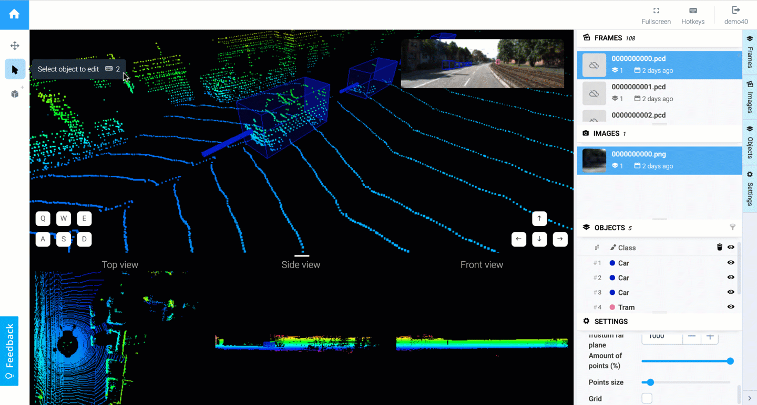

**[Open Source Tools]**

1. **Semantic-Segmentation-Editor (**[**https://github.com/Hitachi-Automotive-And-Industry-Lab/semantic-segmentation-editor**](https://github.com/Hitachi-Automotive-And-Industry-Lab/semantic-segmentation-editor)**)**

Characteristics: web-based labeling tool for both images and point clouds

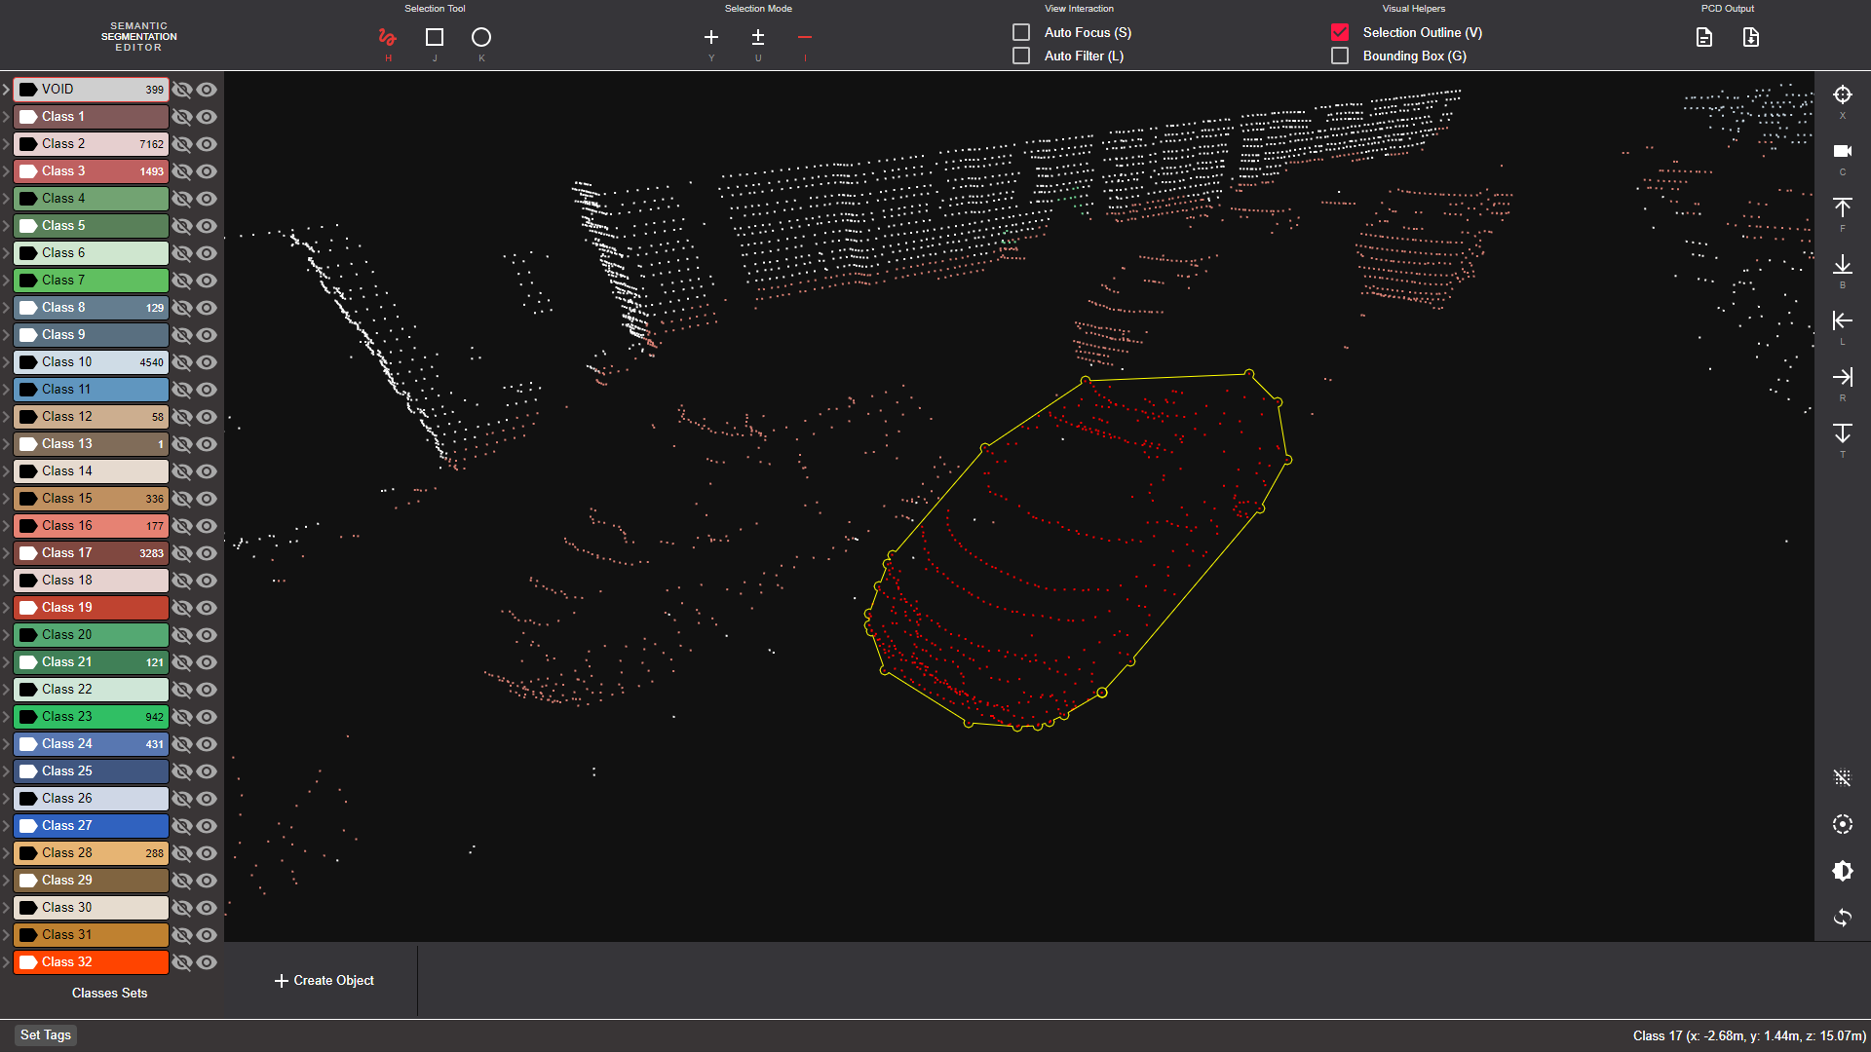

1. **Rviz_Cloud_Annotation (**[**https://github.com/RMonica/rviz_cloud_annotation**](https://github.com/RMonica/rviz_cloud_annotation)**)**

Characteristics: based on the ROS (Robot Operating System) visualizer RViz, letting the user partition a point cloud into parts, each part is assigned a text description

1. LATTE (<https://github.com/bernwang/latte>)

Characteristics: it can accelerate LiDAR point cloud annotation by 6.2x and significantly improve label quality, Sensor Fusion, One-Click Annotation, and Tracking



1. cloud_annotation_tool (<https://github.com/yzrobot/cloud_annotation_tool>)

Characteristics: it’s maintained, semi-automatic labeling function,

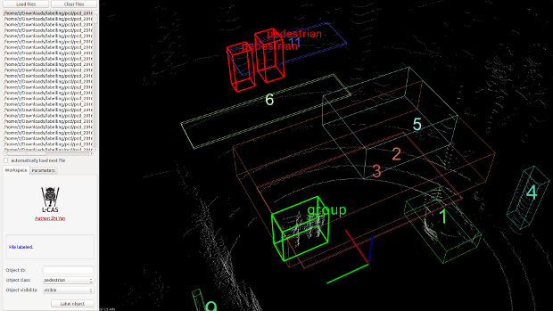

1. point-cloud-annotation-tool (<https://github.com/springzfx/point-cloud-annotation-tool>)

Characteristics: it can be used on both Ubuntu and windows

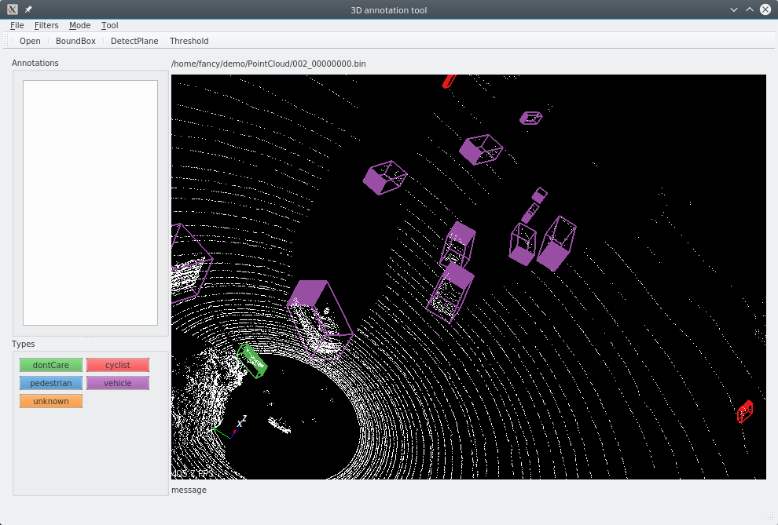

**[Commercial Tools]**

1. **Playment (**[**https://playment.io/3D-point-cloud/**](https://playment.io/3D-point-cloud/)**)**

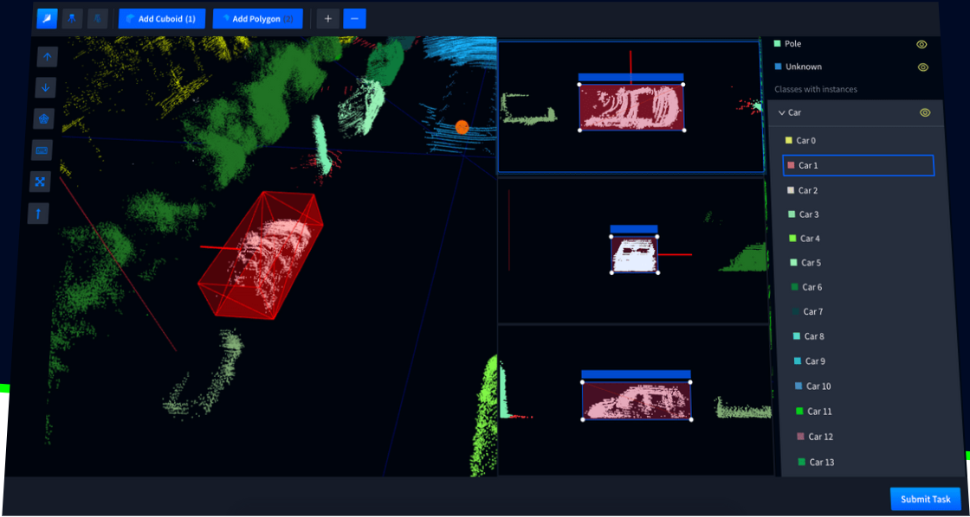

1. **Deepen (**[**https://intercom.help/deepenai/en/articles/2607692-how-to-label-point-cloud-dataset**](https://intercom.help/deepenai/en/articles/2607692-how-to-label-point-cloud-dataset)**)**

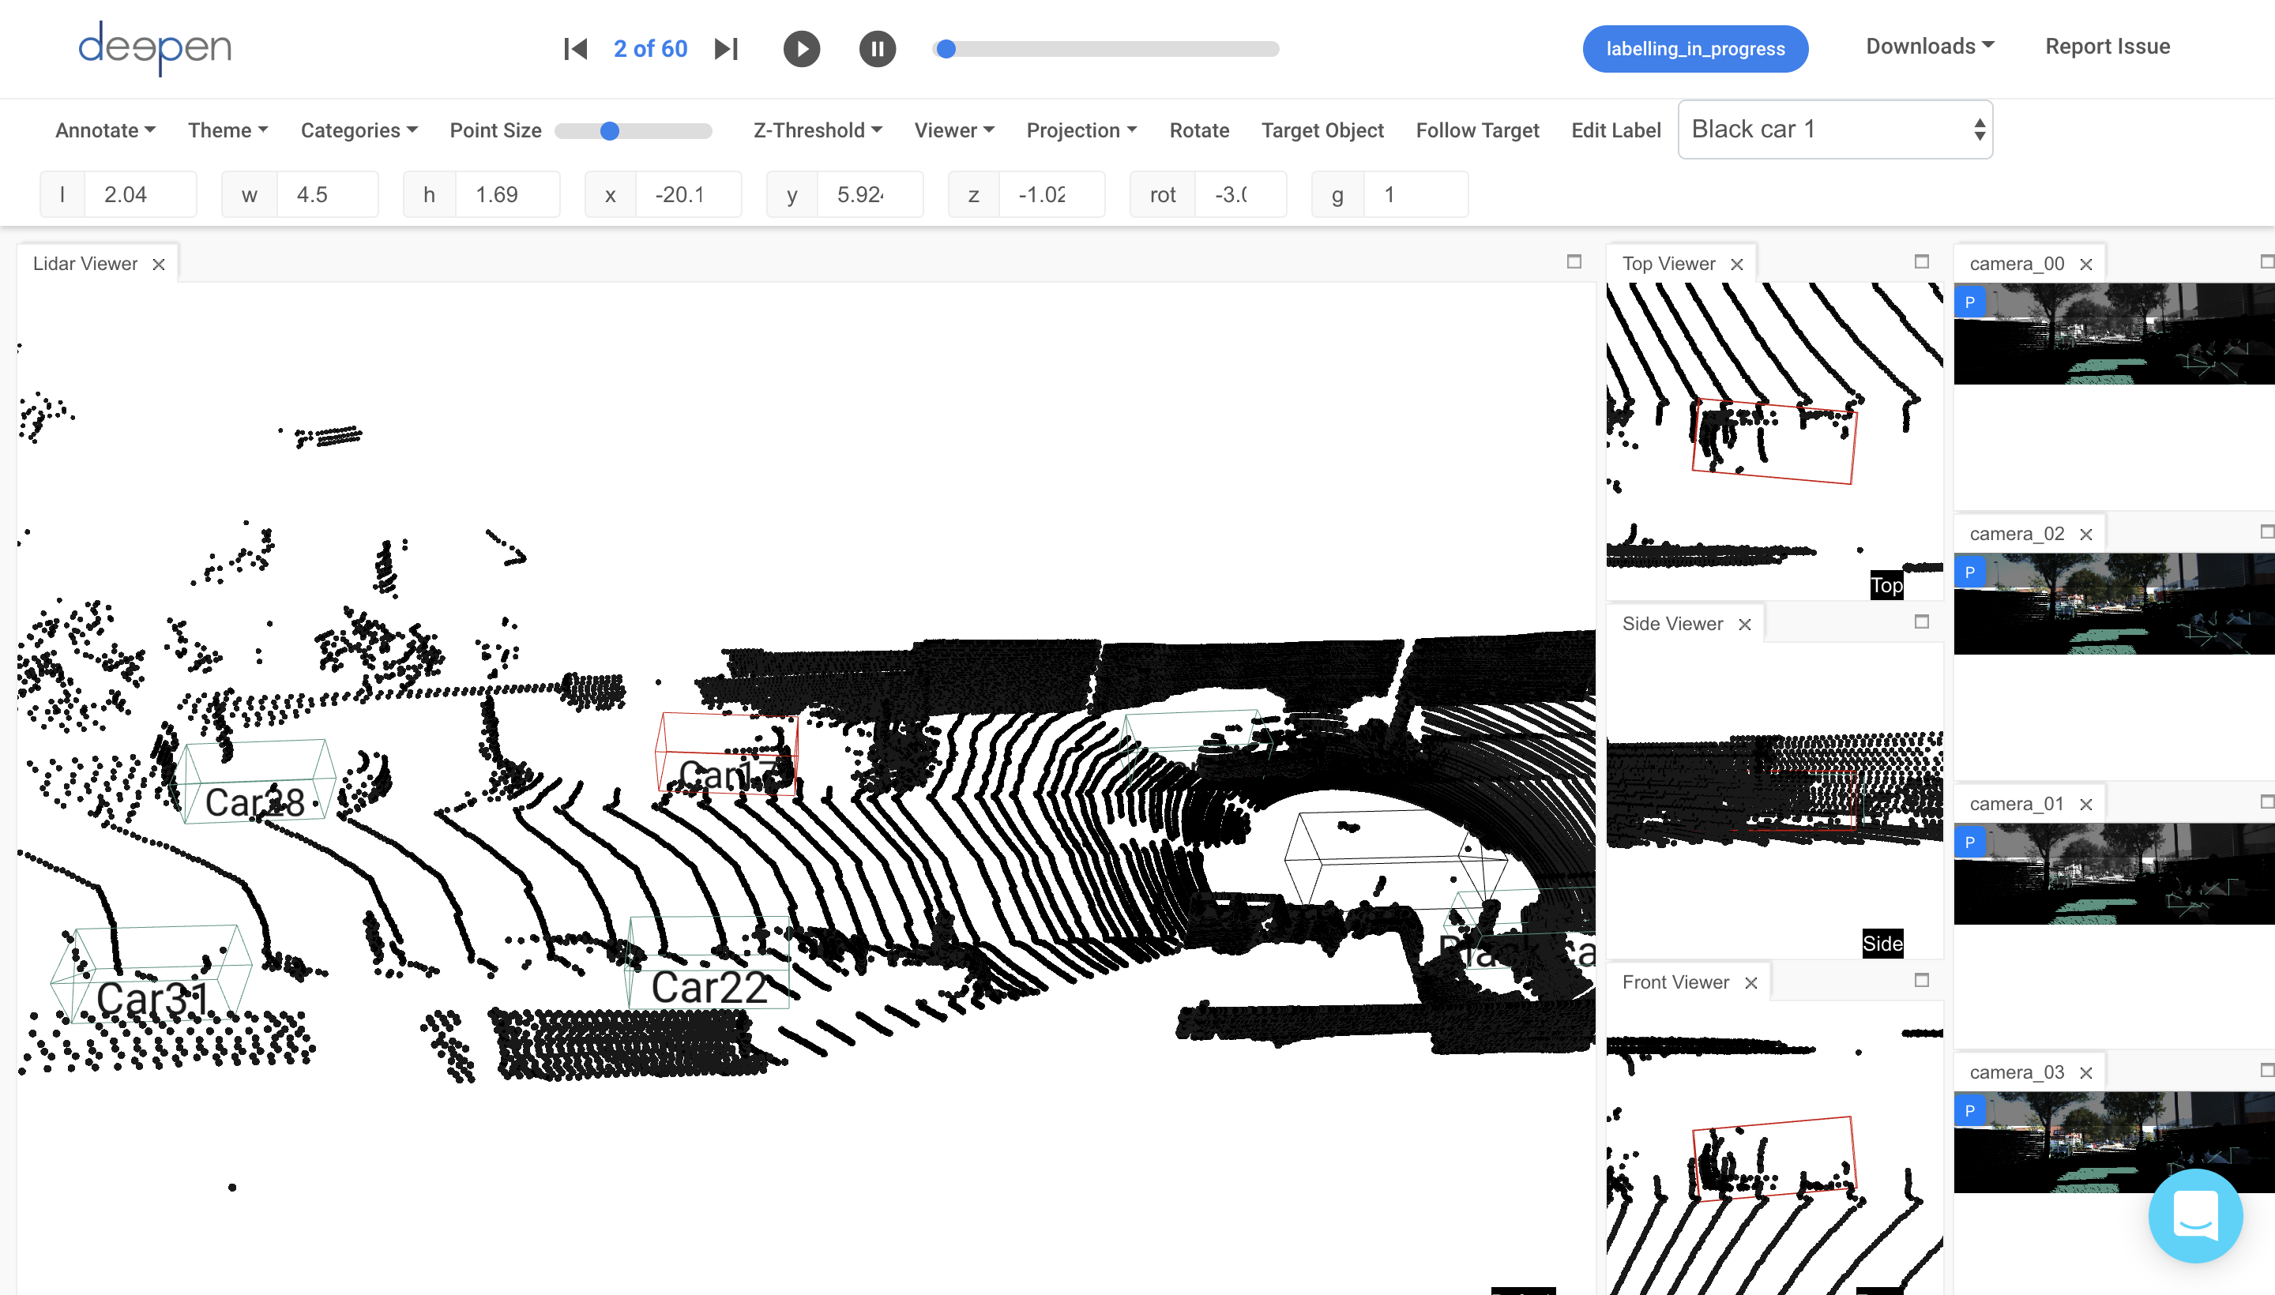

1. **BasicFinder (**[**https://www.basicfinder.com/en/adas/**](https://www.basicfinder.com/en/adas/)**)**

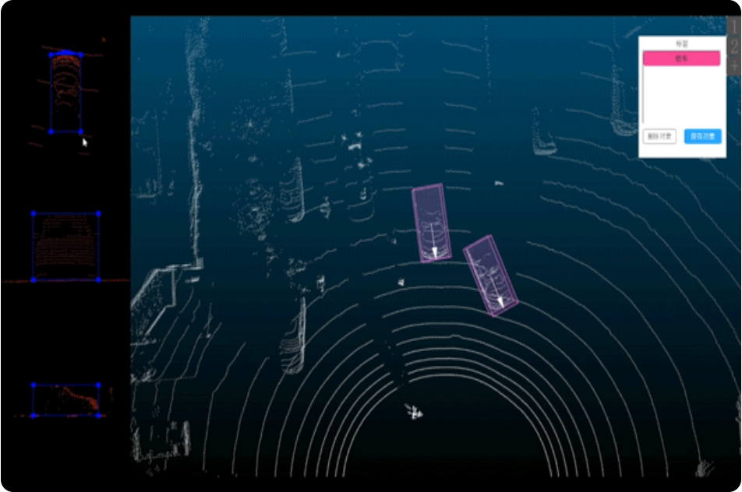

1. Scale (<https://scale.com/>)

